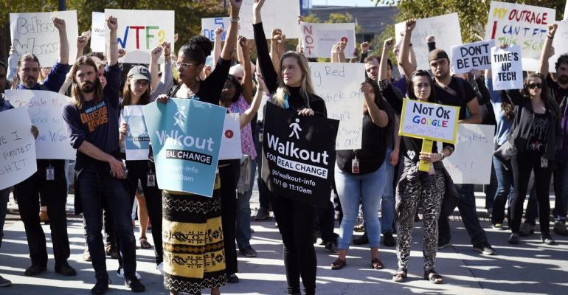

[**SECURITY**](https://www.itprotoday.com/security)**>**[**COMPLIANCE**](https://www.itprotoday.com/security/compliance)

**Google Privately Urged Narrower Protection for Activist Workers**

Google, whose employees have captured international attention in recent months through high-profile protests of workplace policies, has been quietly urging the U.S. government to narrow legal protection for workers organizing online.

[Bloomberg](https://www.itprotoday.com/author/null-Bloomberg) | Jan 24, 2019

(Bloomberg) --Google, whose employees have captured international attention in recent months through high-profile protests of workplace policies, has been quietly urging the U.S. government to narrow legal protection for workers organizing online.

During the Obama administration, the National Labor Relations Board broadened employees’ rights to use their workplace email system to organize around issues on the job. In a 2014 case, Purple Communications, the agency restricted companies from punishing employees for using their workplace email systems for activities like circulating petitions or fomenting walkouts, as well as trying to form a union. In filings in May 2017 and November 2018, obtained via Freedom of Information Act request, Alphabet Inc.’s Google urged the National Labor Relations Board to undo that precedent.

Citing dissents authored by Republican appointees, Google’s attorneys wrote that the 2014 standard “should be overruled” and a George W. Bush-era precedent—allowing companiesto ban organizing on their employee email systems—should be reinstated.

In an emailed statement, a Google spokeswoman said, "We're not lobbying for changes to any rules." Rather, she said, Google's claim that the Obama-era protections should be overturned was "a legal defense that we included as one of many possible defenses" against meritless claims at the NLRB.

If the Labor Board did what Google wanted, “it would have a huge chilling effect,” said Google employee activist Colin McMillen, one of tens of thousands around the world who participated in a November walkout following revelations about the company’s handling of alleged sexual misconduct.  Google’s employee email system played a pivotal role in the organizing for that protest, he said, with more than a thousand workers joining an email list used to plan it. Given that employees are spread around the globe and don’t have most co-workers’ personal emails, he said, company email is key to facilitating workers’ ability to mobilize. McMillen currently works at Google’s Cambridge, Mass. office, but said he had quit his job and his last day is next month.

"It demonstrates that Google leadership is not operating in good faith,” said McMillen. "They can have a town hall and try to say soothing words and get people to not want to quit, but then if in the background they’re not just rejecting carrying out most of the demands of the walkout, but also trying to tamp down our ability to even coordinate and talk to each other about these issues, that’s extremely concerning."

Google has long fostered a culture of employee feedback, allowing open debate in meetings and online forums, where staff have advocated for changes to products and facilities over the company's 20-year history. But the last year has seen an unprecedented wave of concentrated and forceful advocacy from employees, often at direct odds with the positions of management. After Google was awarded a Pentagon contract for using artificial intelligence to analyze drone footage, thousands of employees signed a petition demanding Google remove itself from “the business of war,” nine software engineers refused to work on a security feature that could help the company win more military contracts, and in June the company said it wouldn’t renew its Department of Defense deal. An employee introduced a shareholder resolution to tie executive compensation to diversity and inclusion, while others wrote a letter to their chief executive officer decrying the treatment of sub-contracted staff as “part of a system of institutional racism, sexism, and discrimination.”

On November 1, thousands of Google employees around the world joined a mid-day walkout urging the company overhaul its handling of sexual misconduct and change its governance, including by adding an employee representative to its board. A week later, CEO Sundar Pichai announced the company would make changes including ending forced arbitration for sexual harassment and assault allegations. “Even in difficult times, we are encouraged by the commitment of our colleagues to create a better workplace,” Pichai wrote in an email to employees.

It was three weeks later, without fanfare, and in a case unrelated to the walkout, that Google’s attorneys made their latest filing urging the Labor Board undo the 2014 precedent protecting workers’ ability to organize.“In an email to all of Google, Sundar assured us that he and Google's leadership supported the walkout. But the company's requests to the National Labor Relations Board tell a different story,” organizers of the employee walkout wrote in a statement. “If these protections are rolled back, Google will be complicit in limiting the rights of working people across the United States, not just us.” They asked not to be named for fear of retaliation.

“Google is one of the most open workplaces in the world," the company’s spokeswoman said. "Employees have multiple internal forums to express their views, raise concerns and connect, including thousands of internal communities and tens of thousands of email groups.”

Google's objections to the legal protection for employees organizing via employee email came in filings defending itself against allegations brought by a regional director of the NLRB. In a 2017 complaint, the agency had accused Google of violating federal labor law, including by maintaining workplace policies that infringe on workers’ rights and by making threats against employees. The complaint also alleged that Google violated the law in 2015 by issuing a warning to an employee because of comments made via email and on the company forum G+ “regarding workplace diversity and social justice initiatives, workplace policy viewpoints, and regarding employees’ rights to express their opinion on G+.”

The name of the employee who was disciplined is redacted in the documents produced via FOIA. His attorney, Noah Peters, said that the employee declined to comment or to identify himself. Peters said that his client was punished by Google for dissenting from the company's "very, very left-wing office culture" and for sticking up for co-workers who didn't conform to the "tribal" political correctness there. Chris Baker, an attorney representing another worker whose claims against Google are part of the same NLRB case, declined to comment. “This case is without merit and we are defending the claim vigorously," Google's spokeswoman said.

Google has denied the NLRB’s allegations of wrongdoing. In a filing responding to the NLRB, it says the employee it disciplined had committed misconduct which “interfered with Google’s lawful interest in maintaining an inclusive workplace for women and minorities that is free of unlawful bias, discrimination, and harassment.” Google also wrote that the NLRB should reverse some of the legal precedents being used against it, including the Purple Communications standard. It is not uncommon for companies to challenge legal precedents being used in cases against them.

The protection established in Purple Communications is “pretty fundamental” given the centrality of email to modern workplace communications, said Wilma Liebman, who chaired the NLRB during Obama’s first term. Given Google’s rhetoric about “the free exchange of ideas, and itself as a purveyor of mechanisms for communications,” she said, “That’s an irony that Google, of all companies, would take such a narrow position.”

The relationship between anti-harassment policies and workplace free expression has been a flashpoint at Google, where a different employee, engineer James Damore, was dismissed in 2017 after publishing a manifesto on an internal company forum criticizing the company’s diversity policies. Damore filed a complaint of his own with the NLRB, but an associate general counsel at the Labor Board concluded that while much of Damore’s essay was likely protected by law, Google was within its rights to terminate him over other portions of it that were “so harmful, discriminatory, and disruptive” as to fall outside the legal protections for collective action at work.

<https://www.itprotoday.com/compliance/google-privately-urged-narrower-protection-activist-workers>